EzPlay Project Plan Draft

Bug Slayers Team

Team Members

Michael Fuentes
Christopher Ledford
Emirhan Tektas

Date: 2/11/2026

Table of Contents
Introduction 3
Scope and purpose of document 3
System Scope 3
Problem/Opportunity Description 3
Anticipated Business/Personal Benefits 3
System Capabilities 3
System Context 3
Schedule 3
Staff Organization 4
Team Structure 4
Tracking and control mechanisms 4

Introduction

Scope and purpose of document (MF)
This document contains the scope, schedule, and organization of EzPlay, as well control mechanisms and communication methods being used to develop the application. The Scope section discusses EzPlay’s features, benefits, and place in the market. The Schedule section provides details on our goals, in particular deadlines and processes. The Staff Organization section will go through the team formation and each role assigned to the members of the Bug Slayers team. Finally, the Tracking and Control Mechanism section lists ways the team communicates and the applications/tools that we will be using over the course of the project.

EzPlay is a gaming platform and application that focuses on gaming with friends. We provide accessibility features that can let anyone play, regardless of the device specifications. In addition, we provide built-in software to improve your gaming experience with friends. Features will be further discussed in the System Scope section.

System Scope

Problem/Opportunity Description (CL)
In short, the simple goal of EzPlay is to get gamers playing video games. We want to lower the ever-rising entry barrier to playing video games. Video games and consoles are all getting more expensive, and even RAM, a core PC component for gaming, is now rising in price. Through our simple, all-in-one program we hope for more people to be able to join the video gaming market.

We have a feature for deal tracking, to lessen the literal cost of gaming. We have a lightweight installation feature, to make it so even cheap gaming systems can still be used to play with others. We have a cloud gaming feature, in which those with weak systems can still play games, and even play games with their friends. All of this is to further facilitate the playing experience.

Anticipated Business/Personal Benefits (CL)
We hope to create a tight social gaming ecosystem revolving around EzPlay. Our program should contain any social feature users could want and ask for, all in one comprehensive package. EzPlay will become a favored gaming application because of its features that can currently only be achieved by downloading and running multiple resource intensive programs. Through this we will create a dedicated userbase. Over time, we will look into more potential features to add to expand our reach and cover more bases.

The users will receive a very consumer-friendly program in which they can easily find new ways to play. They will be able to install features they wish to use from EzPlay, which will further be described in the next section. They will be able to buy games for cheap using our deal tracker, play games even with weak systems through cloud gaming, and chat with their friends. Users will be motivated to play more games through EzPlay, which creates a positive-feedback loop as more gaming means more usage of EzPlay.

System Capabilities (CL)
Deal Tracker (called “DealPlay” within the program): Our deal tracker will connect to various gaming storefronts hosted on the web. This will include Amazon, Steam, Nintendo eShop, Playstation Store, and the Microsoft Store, covering the core storefronts used by PC, Nintendo, Playstation, and Xbox gamers. Through the summation of these storefronts, users will be able to find what platform a video game is the cheapest, which is quite important as many gamers nowadays have multiple gaming systems. When a deal is clicked, it will shift the user to the website hosting the deal, as EzPlay itself is not where the games are bought. Think of it like those deal browser add-ons which suggest cheaper websites to buy a product on when you go online shopping. In this case, however, we host software dedicated to this feature, focused entirely on a specific product type, video games. Users will be able to favorite a game and receive notifications when it goes on sale on any storefront, and even be able to see its lowest recorded price to know when a game could go on an even lower sale before buying. We will also have the compatibility to later-add physical stores such as Walmart or BestBuy, as these stores also have large gaming discounts, and typically host more unique deals and promotions when compared to online gaming storefronts. To sum it all up, the deal tracker will motivate users to buy more games by allowing users to consistently buy games for cheap.

Cloud Gaming (called “CloudGaming” within the program): Our cloud gaming feature will be similar to most other cloud gaming experiences out there. It will connect the user to a hosted platform running a game, allowing them to play a game through a stronger system, instead of locally. The user does not need to buy any game in specific, as all would be hosted on the cloud gaming system which the user connects to. However, on top of hosting a normal cloud gaming service, we will also host a user-to-user cloud gaming option. This will function similarly to other user-to-user cloud gaming programs out there like Parsec or PlayStation SharePlay. The basic idea is that there may be a multiplayer game out there which only one of two friends have. A cloud network is then created between these two users in which friend #2, who does not own the game, then plays through the cloud on friend #1’s device using the game’s multiplayer system, meaning both friends play through friend #1’s device. The limitation with this feature is that, similar to normal cloud gaming but even more extreme here, a strong network both ways is required. However, in addition to this simpler feature, we will also have an enhanced version available in which friend #1 connects to a game through our cloud gaming service on a specific system, and can invite friend #2 to the same system and play a multiplayer game. This way, only direct connection to our very strong cloud gaming network is required. It is likely that the basic cloud gaming service in addition to this invite feature would be locked behind a subscription (and only 1 friend will need to own the subscription to invite another), however the basic user-to-user cloud gaming feature will be available for free.

Social Features (Called “PlayRoom” within the program): Users will be able to add each other as friends, allowing them to set up messages and voice calls in a group of friends. It will be similar in essence to most other social apps and programs, but with a few extra sub-features. EzPlay will have a simple clipping system to capture any funny moments experienced while playing with others (or playing in general). Users will be able to customize clip length and give it a keybind, and there will be an extra in-app feature to modify recent clips before exporting them out. For example, you might have your clip sent to go a minute back just in case but you only need to capture something from a few seconds ago, the minute clip will be stored in the EzPlay program and can be trimmed down to just the past few seconds. This is a combination of other simple clip systems but with a very barebones in-app editor allowing the user to slightly tweak clips. Users can also play games in PlayRoom. Games are listed under a “Toybox” section of the screen. These games are intended to be played with others. When a game is started, others within the same group where the game was started are able to join your game and play with or against you.

Lightweight Installations / Installation Configuration: The core features of EzPlay can all be individually configured, and can all be individually installed or deleted based on what features the user of EzPlay is looking to use. When installing EzPlay, the user will be prompted to select which features they wish to install. Many apps have features like this, however, it is something that social apps such as Discord lack. As a result, gamers have their systems take up an unnecessary amount of resources when they are simply trying to communicate with their friends while playing games. Even the presence of a messaging system is something that may take up unnecessary resources for some. And by creating a program which, at its core, is made up of building blocks that can be taken away at ease, it will also be easy to add features down the line without annoying existing users of EzPlay who may not want more features due to the resources they would take up. And as the program would have a fairly small installation size, it would be simple for users to modify their existing installation of EzPlay to remove or add back features at will, depending on their current needs. Core features that can be added or removed from the program are the deal tracker, cloud gaming launcher, voice chat/messaging system, and clipping system. In addition to this, smaller things like the PlayRoom’s game system can be disabled within PlayRoom’s settings.

System Context (CL)
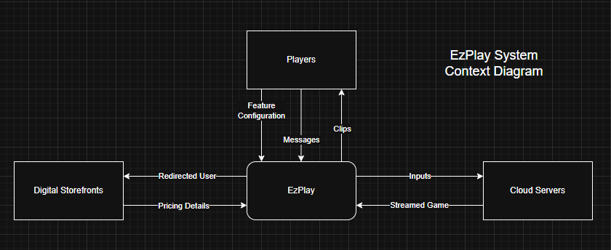
If Not Showing, See Additional Files

Schedule (MF)
See Additional Files

Staff Organization (MF)
The EzPlay project team is organized as such:
Michael Fuentes - Project Leader
Christopher Ledford - Schedule Manager
Emirhan Tektas - File Manager

Tracking and control mechanisms (ET)
Our project team will use tools like Slack, Discord, and Trello to communicate and track project progress. Our main general communication tool is Slack, where we summarize class objectives, discuss course of action, and jot down ideas for EzPlay. Discord is our meeting app, where we are able to talk and share screens. Weekly meetings are held in Discord, from 12:30 to 1:30, depending on availability and need. Trello is our scheduling tool available to everyone on the team so we can visually keep track of goals.

Our team will also use Google Drive and Github as control mechanisms. Our team project folder in Google Drive will be our main hub for gathering and uploading documents so that members of our team have quick access to them. Github will act as our official repository, which holds all versions of our documents related to EzPlay. This allows us to keep track of the changes made to our project documents and lets everyone in the team make changes that can be reviewed by the project leader.

